**BIOMETRIC MIRROR - EXPLORING ATTITUDE TOWARDS FACIAL AND OBJECT ANALYSIS**

**PROJECT REPORT**

**(PHASE- I)**

Submitted by

**P.BHARATHI REG. NO: 19TH0411**

**R.GAJALAKSHMI REG. NO: 19TH0422**

**S.JAYAPRIYA REG. NO: 19TH0431**

**Under the Guidance of**

**Dr. A. MEIAPPANE, M.Tech., Ph.D**

Professor

*in partial fulfillment for the award of the degree of*

**BACHELOR OF TECHNOLOGY**

**in**

**DEPARTMENT OF INFORMATION TECHNOLOGY**



**MANAKULA VINAYAGAR INSTITUTE OF TECHNOLOGY**

**KALITHEERTHALKUPPAM, PUDUCHERRY- 605 107.**

**PONDICHERRY UNIVERSITY**

**INDIA**

**JANUARY - 2023**

**MANAKULA VINAYAGAR INSTITUTE OF TECHNOLOGY**

**PONDICHERRY UNIVERSITY**

**DEPARTMENT OF INFORMATION TECHNOLOGY**

**BONAFIDE CERTIFICATE**

This is to certify that the Project work titled **“BIOMETRIC MIRROR EXPLORING ATTITUDE TOWARDS FACIAL AND OBJECT ANALYSIS”** is a bonafide work done by Ms. **P**.**BHARATHI [Reg. No. 19TH0411],** Ms. **R**.**GAJALAKSHMI [Reg. No. 19TH0422],** Ms. **S.JAYAPRIYA [Reg.No. 19TH0431**] in partial fulfillment of the requirement for the award of the degree of Bachelor of Technology in Information Technology by Pondicherry University during the academic year 2022-23.

Project Guide Head of the Department

( Dr. A. MEIAPPANE) (Dr. P. SIVAKUMAR)

*Submitted for the project work- Phase-I- Viva Voce Examination held on*.............................

ACKNOWLEDGEMENT

We express my sincere thanks to our Chairman and Managing Director Shri. M. DHANASEKARAN, for all his encouragement and moral support. We thank our Vice Chairman Shri. S.V. SUGUMARAN, and our secretary Dr. K. NARAYANASAMY for their constant encouragement.

It gives us great pleasure to convey our deep and sincere thanks to our Principal Dr. S. MALARKKAN, for giving constant motivation in succeeding our goal.

We extend our sincere and heartfelt thanks to our Head of Department **Dr. P. SIVAKUMAR,** Professor**,** Department of Information Technology, for providing the right ambience for carrying out this project work.

We would like to thank our guide **Dr. A. MEIAPPANE,** Professor, Department of Information Technology, providing his valuable guidance and suggestions for our project work. We thank his for the continuous encouragement and the interest shown on us to bring out our project work successfully.

We would like to express my gratitude to all teaching and non-teaching staff members of our department. And above all, the blessings of the Almighty have kept up my spirit and enabled me to complete my study successfully.

**R.GAJALAKSHMI**

**P.BHARATHI**

**S.JAYAPRIYA**

**ABSTRACT**

Now-a-days with the continued development of artificial intelligence facial emotion recognition has become more popular. The emotion recognition plays a major role in interaction technology. In interaction technology the verbal components only play a one third of communication and the non-verbal components plays a two third of communication. A facial emotion recognition (FER) method is used for detecting facial expressions. Facial expression plays a major role in expressing what a person feels and it expresses inner feeling and his or her mental situation or human perspective. The existing system for this project comprises a FER system using CNN classifier which suffers from many disadvantages of limited accuracy, limited dataset and limited flexibility. Deep Neural Network(DNN) through feature learning perform data representation well and have gained many successes in learning and complex problems, many studies have been done on the application of deep neural networks to face recognition and many successes has been achieved. This project aims to identify basic human emotions with the combination of gender classification and age estimation. The facial emotions such as happy, sad, angry, fear, surprised, neutral emotions are considered as basic emotions. We have chosen main dataset which is namely ONNX and YOLO. The success of the face and object analysis project is evaluated using appropriate evaluation metrics, such as accuracy, sensitivity and specificity.

**TABLE OF CONTENTS**

|  |  |  |
| --- | --- | --- |
| **CHAPTER NO** | **TITLE** | **PAGE NO** |
|  | **BONAFIDE CERTIFICATE** | ***ii*** |
|  | **ACKNOWLEDGEMENT** | ***iii*** |
|  | **ABSTRACT** | ***iv*** |
|  | **LIST OF FIGURES** | ***viii*** |
|  | **LIST OF TABLES** | ***ix*** |
|  | **LIST OF ABBREVIATIONS** | ***x*** |
| **1** | **INTRODUCTION** | 1 |
|  | 1.1 OVERVIEW | 1 |
|  | 1.1.1 Problem Identification | 2 |
|  | 1.2 CHALLENGES IN DOMAIN | 2 |
|  | 1.3 OBJECTIVE OF THE PROJECT WORK | 3 |
|  | 1.4 NEED/SCOPE FOR THE PROJECT WORK | 4 |
|  | 1.5 ORGANIZATION OF THE CHAPTERS | 5 |
| **2** | **LITERATURE SURVEY** | 6 |
|  | 2.1 SURVEY OF THE RELATED WORKS | 6 |
|  | 2.1.1 Biometric Mirror: Exploring values and Attitudes towards Facial Analysis and Automated Decision making. | 6 |
|  | 2.1.2 Facial Emotion Detection Using Deep Learning | 6 |
|  | 2.1.3 Facial Expression Recognition Based Using Deep Neural Network | 7 |
|  | 2.1.4 Real Time Facial Expression Recognition Based On Deep Neural Network | 7 |
|  | 2.1.5 Emotion Recognition using Deep Neural Network with Vectorized Facial Features | 8 |
|  | 2.2 TECHNIQUES / ALGORITHM | 8 |
|  | 2.2.1 Deep Neural Networks | 8 |
|  | 2.2.2 You Only Look Once | 8 |
|  | 2.3 SUMMARY OF LITERATURE REVIEW | 10 |
| **3** | **SYSTEM REQUIREMENTS** | 13 |
|  | 3.1 HARDWARE REQUIREMENTS | 13 |
|  | * 1. SOFTWARE REQUIREMENTS | 13 |
|  | * 1. ABOUT THE SOFTWARE | 14 |
|  | 3.3.1 Visual Studio | 14 |
|  | 3.3.2 Onion Framework | 14 |
| **4** | **EXISTING SYSTEM** | 15 |
|  | 4.1 CONVOLUTIONAL NEURAL NETWORKS OVERVIEW | 15 |
|  | 4.2 CONVOLUTIONAL NEURAL NETWORKS ARCHITECTURE | 15 |
|  | 4.3 DRAWBACK/ISSUES IN CONVOLUTIONAL NEURAL NETWORKS | 16 |
|  | 4.4 PROBLEM STATEMENT | 17 |
| **5** | **PROPOSED SYSTEM** | 18 |
|  | 5.1 OVERVIEW OF DEEP NEURAL NETWORKS | 18 |
|  | 5.2 ARCHITECTURE DIAGRAM OF DEEP NEURAL NETWORKS | 18 |
|  | 5.3 LIST OF MODULES | 19 |
|  | 5.3.1 Image Acquisition | 19 |
|  | 5.3.2 2D to 3D Conversion | 20 |
|  | 5.3.3 Face Detection and Fuzzy Down-Sampling | 20 |
|  | 5.3.4 Feature Extraction | 21 |
|  | 5.3.5 Feature Selection | 21 |
|  | 5.3.6 Deep Neural Network (DNN) Classifier | 22 |
|  | 5.4 DATASETS | 24 |
|  | 5.4.1 Onnx | 24 |
|  | 5.4.2 Darknet | 24 |
|  | 5.4.3 Utk Dataset | 24 |
|  | 5.5 PERFORMANCE ANALYSIS | 25 |
|  | 5.5.1 Performance Metrics | 25 |
| **6** | **CONCLUSION** | 26 |
|  | **REFERENCES** | 27 |

**LIST OF FIGURES**

|  |  |  |
| --- | --- | --- |
| **FIGURE NO** | **TITLE** | **PAGE NO** |
| Figure 2.1 | YOLO Diagram | 9 |
| Figure 4.2 | Convolutional neural network Architecture | 15 |
| Figure 5.1 | Deep Neural Network Architecture | 18 |
| Figure 5.2 | Image Acquisition | 19 |
| Figure 5.3 | 2D to 3D Conversion | 20 |
| Figure 5.4 | Fuzzy Down Sampling | 20 |
| Figure 5.5 | Feature Extraction | 21 |
| Figure 5.6 | Feature Selection | 22 |
| Figure 5.7 | DNN Classifier | 22 |

**LIST OF TABLES**

|  |  |  |
| --- | --- | --- |
|  |  |  |
| |  |  |  | | --- | --- | --- | | **TABLE NO** | **TITLE** | **PAGE NO** | | Table 1.1 | Summary of Literature Review | 10 | | Table 5.1 | Various techniques used in modules | 23 | | Table 5.2 | Various Datasets and Predictions | 24 | |  |  |
|  |  |  |

**LIST OF ABBREVIATIONS**

|  |  |
| --- | --- |
| ONNX | Open Neural Network Exchange |
| CNN | Convolutional Neural Networks |
| DNN | Deep Neural Networks |
| YOLO | You Only Look Once |
| PCA | Principal Component Analysis |

**CHAPTER 1**

**INTRODUCTION**

Facial expression recognition is a technique done via human beings or computers, which includes finding faces in the scene called face detectiondatabase. It has gained great progress in the recent years due to improvement in design and learning of features and face recognition models. As humans have an exceptional ability to recognize people irrespective of their age, lighting conditions and varying expressions.

The aim of researchers is to design an FR system which can match or even surpass the human recognition rate which is nearly 97.5%. The techniques used in best facial recognition systems may depend on the application of system. Face recognition systems may be divided into two broad categories: Find a person from his image in a large database of facial images (eg.a police database).

These systems 64 Deep Neural Network for Human Face Recognition returns the details of the person being searched for. Often only one image is available per person. It is usually not necessary for recognition to be done in real time. Identify a person in real time.

These are used in systems which allow access to a certain group of people and deny access to others.

Multiple images per person are often available for training and real time recognition is required. The proposed idea is for the second type of systems with varying facial details, expressions, and angles. It remains an open problem to find an ideal facial feature which is robust for FR in unconstrained environments.

**1.1 OVERVIEW**

* Face Emotion recognition (FER) system identifies a face by matching it with the facial In this Project, we explore using Deep Neural Network and device getting to know.
* Facial Expression recognition algorithm is advanced to analyze a various type of human expressions- satisfied, unhappy, indignant and amazed.
* Object detection algorithm is advanced to analyze a various type behind Objects along with Human Face.
* ONNX and Darknet dataset is used for train the database. This facial features popularity device is observed to be 98% correct in studying the human emotion.
  + 1. **Problem Identification**
* The Biometric Mirror scans people faces and uses AI to compare their faces against

a database of other faces to produce a personality profile of the scanned person.

* The reports include ratings for the individual responsibility, happiness, aggression,

attractiveness, weirdness, and emotional stability.

* The project was created for the purpose of examining the ethics of such systems, not

to commercialize it.

* The technology provides opportunities to infer personal characteristics from faces in

photos, video recording, and camera feeds.

**1.2 CHALLENGES IN DOMAIN**

Up to now, progress in deep learning has mainly been achieved exploring architectural variants validated on an experimental basis only. Few attempts have been made to understand why and how deep learning obtains such impressive performance. Full understanding of how to choose structural features as well as how to efficiently tune hyper-parameters of models (typically performed through a validation set or a cross-validation approach thanks to extremely expensive, from a computational point of view, procedures) is still far from being a reality.

A specific framework for assessment of unsupervised learning is also needed. Evolving (dynamically adapting structure) type deep learning networks constitute a specific challenge. Another important issue concerns computational efficiency. Currently deep models need a significant amount of computational burden to reach state-of-theart performances on medium/large size datasets and mainly for off-line environments. Nowadays, however, the amount of available data is growing at a rapid pace.

A step forward in this direction is to consider online learning from streams of data. Dealing with a stream of data requires the use of bounded constant memory and almost linear time for learning on single input item. While constant memory may not be a relevant issue for a deep network due to the fact that most of the network architectures are static, i.e. the topology of the network is defined before learning takes place and does not change with time, the constraint on time complexity constitutes a serious challenge.

If we look at the nature of data for future applications of deep learning technologies, it is evident that more and more application domains involve data which can naturally be represented in structured form, such as sequences (time series, audio and video signals, DNA, etc.), trees (XML documents, parse trees, RNA, etc. )

Due to the high combinatorial complexity underpinning structured domains, computationally efficient models to learn relations among structured information at different levels of abstraction are needed. An interesting approach to study could be the development of deep versions of Reservoir Computing models. Incremental approaches provide another research alternative, e.g. exploiting the framework introduced in.

**1.3 OBJECTIVE OF THE PROJECT WORK**

* The objective of face emotion recognition using Deep Neural Networks (DNN) is to train a model that can accurately recognize human emotions based on facial expressions.
* This is a task in the field of computer vision and is useful for a wide range of applications, including but not limited to, human-computer interaction, marketing research, and psychology research.
* The DNN model is trained using a dataset of labeled facial expressions, which may include a range of emotions such as happiness, sadness, anger, surprise, fear, and disgust.
* The model uses the images of the face as input and learns to recognize patterns that correspond to different emotions. Once trained, the model can be used to classify the emotions of a new image of a face.
* The objective of object detection is to develop an system that can automatically identify and locate objects of interest in an image or video.
* Object detection in DNNs typically involves training a model to classify objects and predict their bounding boxes in an image or video.
* Object detection is a critical task in computer vision and has many real-world applications such as autonomous driving, video surveillance, robotics, and medical imaging.
* Both face emotion recognition and object detection are challenging tasks in computer vision that require sophisticated algorithms and deep learning models. These tasks involve processing large amounts of image and video data and require the ability to accurately detect and classify complex patterns in the data.

**1.4 NEED/SCOPE FOR THE PROJECT WORK**

* Security and surveillance: Face emotion recognition and object detection can be used in security and surveillance applications to detect and classify suspicious activities or people.
* Automotive: Object detection can be used in autonomous vehicles to detect and avoid obstacles, while face emotion recognition can be used to improve driver safety and comfort.
* Healthcare: Face emotion recognition can be used to detect patient distress or pain, while object detection can be used to identify and track medical equipment and supplies.
* Retail: Object detection can be used in retail environments to track inventory and detect shoplifting, while face emotion recognition can be used to analyze customer behavior and improve marketing strategies.
* Entertainment: Face emotion recognition can be used in gaming and virtual reality applications to create more realistic and engaging experiences.
* Human resources: Face emotion recognition can be used in recruitment and hiring to analyze candidate behavior and identify the best fit for a given role.

**1.5 ORGANIZATION OF THE CHAPTERS**

For the proper presentation of the work, the project will be divided into six(6) chapters.

**In Chapter 1** will cover the introduction which talks about the background of the project, overview of the project, challenges in domain, objective of the project work, scope of the project.

**In Chapter 2** will deal with review of related Literature topics, survey of the related works, techniques or algorithms used in existing literature and overall summary.

**In Chapter 3** will deal with system requirements which includes hardware requirements and software requirements.

**In Chapter 4** will look at the existing system overview, architecture diagram, limitations in existing system and problem statement for the project.

**In Chapter 5** will deal with the proposed system overview, architecture diagram, list of modules, dataset used in this project and performance analysis.

**In Chapter 6** will deal with conclusions and future scope of the project

**CHAPTER 2**

**LITERATURE SURVEY**

**2.1 SURVEY OF THE RELATED WORKS**

**2.1.1 Biometric Mirror: Exploring values and Attitudes towards Facial Analysis and Automated Decision making**

**Author:** Niels Wouters , Ryan Kelly

**Year:** 2019

**Paper:** ResearchGate Journal

**DESCRIPTION:**

In this paper, we discuss Biometric Mirror, a case study that explored opinions about the ethics of an emerging technology. The interactive application distinguished demographic and psychometric information from people’s facial photos and presented speculative scenarios with potential consequences based on their results. We analyzed the interactions with Biometric Mirror and media reports covering the study. Our findings demonstrate the nature of public opinion about the technology’s possibilities, reliability, and privacy implications. Our study indicates an opportunity for case study-based digital ethics research, and we provide practical guidelines for designing future studies.

**2.1.2 Facial Emotion Detection Using Deep Learning**

**Author:** Akriti Jaiswal, A. Krishnama Raju, Suman Deb

**Year:** 2020

**Paper**: IEEE Conferernce.

**DESCRIPTION:**

Deep learning (DL) based emotion detection gives performance better than traditional methods with image processing. This paper presents the design of an artificialintelligence (AI) system capable of emotion detection through facial expressions. It discusses about the procedure of emotion detection, which includes basically three main steps: face detection, features extraction, and emotion classification. This paper proposed a convolutional neural networks (CNN) based deep learning architecture for emotion detection from images. The performance of the proposed method is evaluated using two datasets Facial emotion recognition challenge (FERC-2013) and Japaness female facial emotion (JAFFE). The accuracies achieved with proposed model are 70.14 and 98.65 percentage for FERC- 2013 and JAFFE datasets respectively.

**2.1.3 Facial Expression Recognition Based Using Deep Neural Network**

**Author:**  Junnan Li and Edmund Y. Lam

**Year:**2015

**Paper:** IEEE Conferernce

**DESCRIPTION:**

Develop a technique using deep neural network for human facial expression recognition. Images of human faces are preprocessed with photometric normalization and histogram manipulation to remove illumination variance. Facial features are then extracted by convolving each preprocessed image with 40 Gabor filters. Kernel PCA is applied to features before feeding them into the deep neural network that consists of 1 input layer, 2 hidden layers and a soft max classifier. The deep network is trained using greedy layer-wise strategy. We use the Extended Cohn- Kanade Dataset for training and testing. Recognition tests are performed on six basic expressions (i.e. surprise, fear, disgust, anger, happiness, sadness).

**2.1.4 Real Time Facial Expression Recognition Based On Deep Neural Network**

**Author:**  T. Ambikadevi Amma, M. R. Sruthy,S. Divya,P. Renuka

**Year**:2019

**Paper:** IJRESM Journal

**DESCRIPTION:**

Now a days, emotion recognition plays a major role in interaction technology. In interaction technology the verbal components only play a one third of communication and the non-verbal components plays a two third of communication. A facial emotion recognition (FER) method is used for detecting facial expressions. This paper aims to identify basic human emotions with the combination of gender classification and age estimation. The facial emotions such as happy, sad, angry, fear, surprised, neutral emotions are considered as basic emotions.

**2.1.5 Emotion Recognition using Deep Neural Network with Vectorized Facial Features**

**Author:** Guojun Yang, Jordi Saumell y Ortoneda and Jafar Saniie

**Year:**2018

**Paper:** IEEE Conference

**DESCRIPTION:**

Emotion reveals valuable information regarding human communications. It is common to use facial expressions to express emotions during a conversation. The vectorized facial feature can be used to build an DNN (Deep Neural Network) for emotion recognition. **Using the proposed vectorized facial feature, the DNN can predict emotions with 84.33% accuracy. Nevertheless, compared with CNNs (Convolutional Neural Network) with similar performance, training such DNN requires less time and data.**

**2.2** **TECHNIQUES/ALGORITHMS**

**2.2.1 Deep Neural Networks**

Deep neural networks are ones in which there are multiple hidden layers. Since each hidden layer computes a nonlinear transform of the previous layer, multiple hidden layers have the power to generate much more complex features of the input.

As a result, a deep network can learn significantly more complex functions than a shallow network. It has been shown that a klayer network can represent functions that a (k – 1) layer network can only represent with an exponentially large number of hidden units.

**2.2.2 You Only Look Once**

YOLO (You Only Look Once) is a popular algorithm for object detection in real-time video streams and images. It is based on a deep neural network architecture that predicts object bounding boxes and class probabilities directly from a single image pass. This makes YOLO extremely fast and accurate.

The basic steps involved in using YOLO for object detection are as follows:

1. Input image: Provide an input image to the YOLO3 algorithm. The image can be of any size, but larger images will take longer to process.
2. Network architecture: YOLO uses a deep convolutional neural network to predict object bounding boxes and class probabilities. The network architecture consists of multiple convolutional layers followed by fully connected layers.
3. Preprocessing: YOLO requires the input image to be preprocessed by resizing it to a fixed size and normalizing the pixel values. This ensures that the input data is consistent and the network can learn useful features.
4. Object detection: YOLO predicts object bounding boxes and class probabilities directly from the input image. It does this by dividing the input image into a grid of cells and predicting a bounding box and class probability for each cell.
5. Non-maximum suppression: YOLO predicts multiple bounding boxes for each object in the image, so non-maximum suppression is used to remove overlapping boxes and retain the most confident detection.
6. Output: YOLO outputs a set of bounding boxes and corresponding class probabilities for each detected object in the input image.

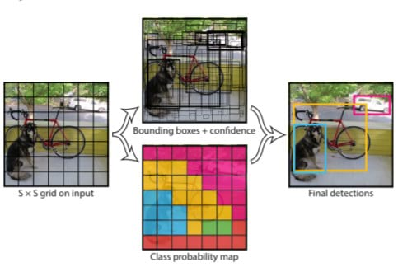

**Figure 2.1 YOLO diagram**

**2.3 SUMMARY OF LITERATURE REVIEW**

Table 2.1 Summary of literature review

|  |  |  |  |
| --- | --- | --- | --- |
| **SI.No** | **Title of the paper** | **Description** | **Issues/ Drawback/ Limitations** |
| 1 | Biometric Mirror: Exploring values and Attitudes towards Facial Analysis and Automated Decision making.  **Author:**Niels Wouters , Ryan Kelly.  **Year:** 2019 /IEEE | The interactive application distinguished demographic and psychometric information from people’s facial photos and presented speculative scenarios with potential consequences based on their results | The main problem with using facial recognition biometrics to login is that the user needs to remove their face mask. Many people don't like the idea o having to remove face masks to access systems in a place that likely requires the use of face masks. |
| 2 | Facial Emotion Detection Using Deep Learning  **Author:**Akriti Jaiswal, A. Krishnama Raju, Suman Deb  **Year:**2020/IEEE | Deep learning (DL) based emotion detection gives performance better than traditional methods with image processing. This paper presents the design of an artificial intelligence (AI) system capable of emotion detection through facial expressions. | Mimics could be to some extent controlled by humans and therefore the recognition results might be intentionally or unintentionally falsified (Landowska and Miler, 2016). Disadvantages of face detection include huge storage requirements, vulnerable detection, and potential privacy issues. |
| 3 | Facial Expression Recognition Based Using Deep Neural Network  **Author:**  Junnan Li and Edmund Y. Lam  **Year**:2015/IEEE | Develop a technique using deep neural network for human facial expression recognition. Images of human faces are preprocessed with photometric normalization and histogram manipulation to remove illumination variance. | The disadvantages of using facial expressions to measure emotions are that most facial expression coding schemes rely on the FACS system traditionally used to classify only the six basic emotions, and are very labor-intensive if done by trained human coders rather than software |
| 4 | Real Time Facial Expression Recognition Based On Deep Neural Network  **Author:**  T. Ambikadevi Amma, M. R. Sruthy,S. Divya,P. Renuka  **Year**:2019/Journal | This paper aims to identify basic human emotions with the combination of gender classification and age estimation. The facial emotions such as happy, sad, angry, fear, surprised, neutral emotions are considered as basic emotions. | Poor Image Quality. The effectiveness of facial-recognition algorithms is influenced by the image quality. Small Image Sizes. Different Face Angles. Data Processing and Storage Issues. |
| 5 | Emotion Recognition using Deep Neural Network with Vectorized Facial Features  **Author:** Guojun Yang, Jordi Saumell y Ortoneda and Jafar Saniie  **Year:**2018  **Paper:**IEEE Conference | Emotion reveals valuable information regarding human communications. It is common to use facial expressions to express emotions during a conversation. The vectorized facial feature can be used to build an DNN (Deep Neural Network) for emotion recognition. Using the proposed vectorized facial feature, the DNN can predict emotions with 84.33% accuracy. Nevertheless, compared with CNNs (Convolutional Neural Network) with similar performance, training such DNN requires less time and data. | It is a challenge to make emotion available in different languages.  Performance and results of the emotion sensing system depends on accuracy of the sensors such as cameras, thermal image sensors, facial recognition algorithm used and so on. Highly accurate system will be expensive due to use of costly components. |

**CHAPTER-3**

**SYSTEM REQUIREMENTS**

**3.1 HARDWARE REQUIREMENTS**

* Processor : Intel Pentium Dual Core 1.8GHz
* System : Pentium Dual Core.
* Hard Disk : 120 GB.
* Monitor : 15’’ LED
* Input Devices : Keyboard, Mouse
* Ram : 8 GB

**3.2 SOFTWARE REQUIREMENTS**

* Operating System : Windows 10/Windows 11
* Coding Language : C#
* Tool : Visual Studio
* Database : MySql
* Framework : Onion

**3.3 ABOUT SOFTWARE**

**3.3.1 Visual Studio**

An integrated development environment (IDE) is a feature-rich program that supports many aspects of software development. The Visual Studio IDE is a creative launching pad that you can use to edit, debug, and build code, and then publish an app. Over and above the standard editor and debugger that most IDEs provide, Visual Studio includes compilers, code completion tools, graphical designers, and many more features to enhance the software development process.

Visual Studio is available for Windows and Mac. [Visual Studio for Mac](https://learn.microsoft.com/en-us/visualstudio/mac/) has many of the same features as Visual Studio for Windows, and is optimized for developing cross-platform and mobile apps. This article focuses on the Windows version of Visual Studio. There are three editions of Visual Studio: Community, Professional, and Enterprise.

With all of these Visual Studio also serves as a testing platform as well. Through this developer can easily test their application how their application is working on target environment and ensure that they do so smoothly once they are deployed.

**3.3.2 Onion Framework**

Onion architecture is **built on a domain model in which layers are connected through interfaces**. The idea is to keep external dependencies as far outward as possible where domain entities and business rules form the core part of the architecture. It provides flexible, sustainable and portable architecture.

The research onion suggests **mono-method, mixed method and multi-method** as possible choices for conducting research. The mono-method comprises only one method for the study. The mixed method is based on the use of two or more methods of research and commonly refers to the use of qualitative and quantitative methodology.

**CHAPTER 4**

**EXISTING SYSTEM**

**4.1 CONVOLUTIONAL NEURAL NETWORK OVERVIEW**

A Convolutional neural network (CNN) is a type of artificial neural network that has one or more convolution layers and are used mainly for image processing, classification, segmentation and also for other auto correlated data. Deep learning is a machine learning based artificial neural network that recognize objects in image by progressively extracting features from data through higher layers. As shown in figure in order to recognize face in an image we have to train the CNN with human faces. The benefit of using CNNs is their ability to develop an internal representation of a two dimensional image. This allows the model to learn position and scale of faces in an image. After train the CNN it can able to recognize face in an image One can effectively use Convolutional Neural Network for Image data. CNN that extracts features in an image.

**4.2 CONVOLUTIONAL NEURAL NETWORK ARCHITECTURE**

**Figure 4.1 Convolutional neural network Architecture**

Here is a high-level overview of a typical architecture:

* Input: The system takes an image or a video stream as input, which may be preprocessed to enhance image quality and remove noise.
* Feature extraction: The input is fed through one or more convolutional layers to extract features from the image. These layers apply filters to the input, which help to identify edges, shapes, and patterns in the image.
* Pooling: The output of the convolutional layers is typically down sampled using pooling layers, which reduce the dimensionality of the feature maps and help to avoid over fitting.
* Soft max Layer: The use of the soft max layer in CNN-based face emotion recognition allows for probabilistic predictions, which can be useful in cases where there is uncertainty or ambiguity in the input. It also enables the use of standard classification metrics such as cross-entropy loss, which can be used to train the model to minimize prediction error.
* Classification: The resulting feature maps are then flattened and fed into one or more fully connected layers for classification. These layers use the extracted features to classify the image as belonging to a particular emotion or object class.
* Output: The system produces an output, which may include the class label or probability scores for each class.

**4.3 DRAWBACK/ISSUES IN CONVOLUTIONAL NEURAL NETWORK**

* Though much progress has been made recognizing facial expression with a high accuracy remains difficult due to the subtlety, complexity and variability of facial expressions.
* Low-resolution images in real world environments make real-life expression recognition much more difficult.
* And we must also consider the factor of time and memory.

**4.4 PROBLEM STATEMENT**

The existing system for this project comprises facial emotion recognition using Convolutional Neural Networks which suffers from the following issues:

* Limited accuracy: Although CNNs can achieve high accuracy in face emotion recognition and object detection, there may still be errors in the predictions. This can be due to several factors, such as variations in lighting, pose, and occlusions, as well as the complexity and variability of emotions.
* Need for large datasets: CNNs require large, diverse datasets for training. Collecting and labeling large datasets for face emotion recognition and object detection can be time-consuming and expensive.
* Limited flexibility: CNNs are designed to work with fixed-size inputs and are less flexible in terms of handling images with different sizes or aspect ratios. This may limit the applicability of the model to real-world scenarios where input images can vary widely in terms of size and aspect ratio.

To overcome the issues, we build a face emotion recognition with the help of Deep Neural Networks (DNN) which results the output with the maximum accuracy and which is done with less time and data.

**CHAPTER 5**

**PROPOSED SYSTEM**

**5.1 OVERVIEW OF DEEP NEURAL NETWORKS**

* The proposed system “Biometric mirror” has two different detection like face emotion detection and object detection. These detection finds the face emotion and object in real time with the help of an algorithm such as Deep Neural Networks and YOLO.
* Facial features will be introduced to represent facial expression. The proposed facial feature model can not only reflect facial expressions correctly, it can also be used for DNN with high efficiency. To test the efficiency of such method, a DNN is trained to recognize some universal expressions.
* Compared with more complicated neural network structures, such as CNNs (Convolutional Neural Network), a DNN can be trained with less data, therefore, to be built quicker. To be more specific, with simpler inputs, a deep neural network can have a simpler structure, hence, can be trained with less data, and quicker.

**5.2 ARCHITECTURE DIAGRAM FOR DEEP NEURAL NETWORKS**

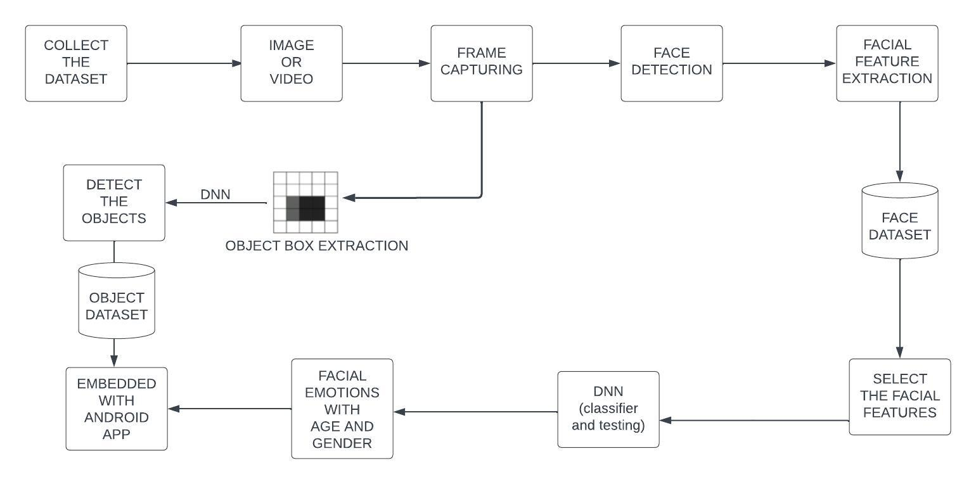

**Figure 5.1 Deep Neural Network Architecture**

**DESCRIPTION:**

* Firstly, we collect the dataset of YOLO and ONNX in the process of Face emotion recognition and object detection.
* Then it compare with input image or video,it produce frame capturing.
* Then frame capture analyze face detection using viola Jones Algorithm with having Face Feature Extractions to face datasets.
* It will extracts the select facial feature using Ada boost Algorithm.
* Next, we select the some facial features for DNN classifier and testing purposes using LDA then process, it will detect the face emotions with some characteristics(Age & gender).
* In this output is embedded with Android Application or web application.

**5.3 LIST OF MODULES**

The list of modules in the proposed system includes image acquisition, 2d to 3d Conversion, fuzzy down sampling, feature extraction, feature selection and deep neural networks.

**5.3.1 Image Acquisition**

* Before any video or image processing can commence an image must be captured by a camera and converted into a manageable entity.
* This is the process known as image acquisition.

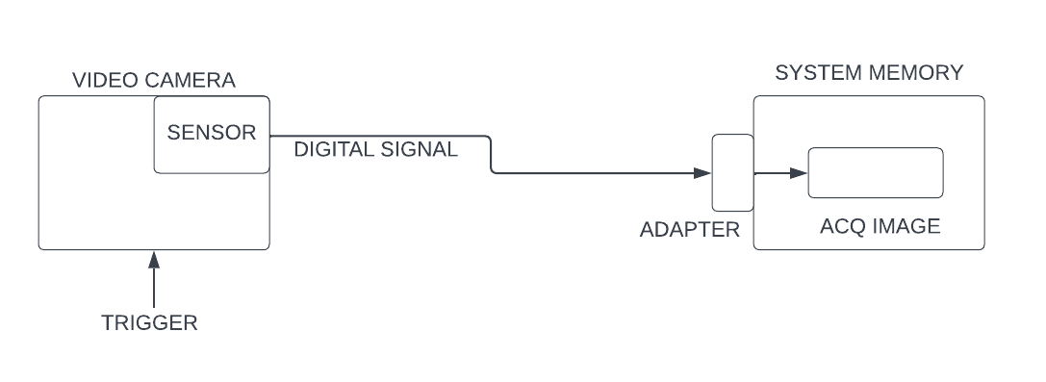

**Figure.5.2 Image Acquisition**

**5.3.2 2d To 3d Conversion**

* In this process we are converting the 2d co-ordinates image into 3d coordinates for better processing in the segmentation process.
* This 2D to 3D conversion help us to get give more details about the affected region in the image.
* Rendering a second stereoscopic view from a monocular image sequence, which is also known as 2D/3D conversion, is a promising way to achieve high quality stereo motion pictures.
* Over the past years it has been shown that for certain recording conditions the conversion can be achieved fully automatically.

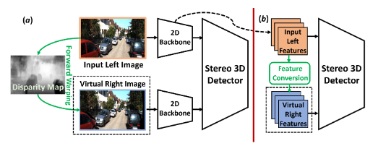

**Figure 5.3 2D to 3D Conversion**

**5.3.3 Face Detection and Fuzzy Down-Sampling**

* + Face Detection component was implemented by Viola Jones.
  + Image is rescaled to 64 * 64 px by Fuzzy Down Sampling.

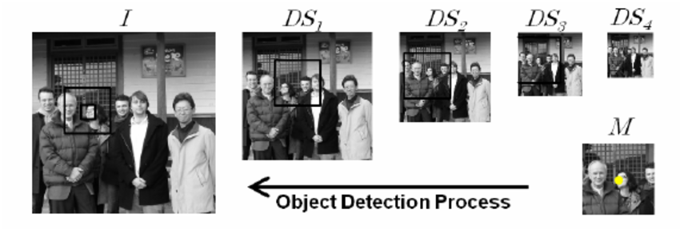

**Figure 5.4 Fuzzy down Sampling**

**5.3.4 Feature Extraction**

* Feature extraction is a special form of dimensionality reduction.
* Extract features from the Face through the evaluation of their weights in different related domains. The feature extraction is a preprocessing stage of the knowledge discovery.
* This preprocessing step aims at converting the face review features into a set of specific features and, at the same time, enriching their semantic characteristics.

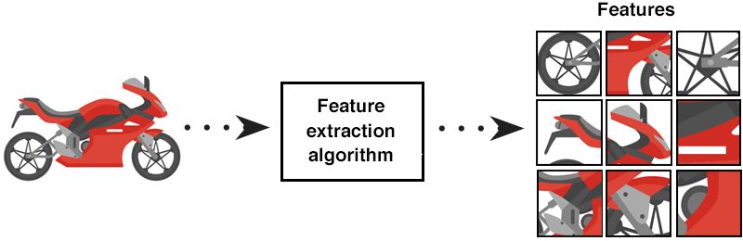

**Figure 5.5 Feature Extraction**

**5.3.5 Feature Selection**

* It involves selecting the most relevant and informative features from the available input data, which helps in improving the accuracy and performance of the model.
* One approach is to use a pre-trained DNN to extract features from the input images, and then apply feature selection techniques such as PCA (Principal Component Analysis) or LDA (Linear Discriminant Analysis).
* Feature selection is an important step in face emotion recognition using DNN, and can help in improving the accuracy and efficiency of the classification model.
* Eg: Selects the most relevant part of face where the emotions can be classified.

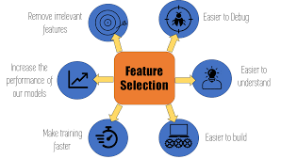

**Figure 5.6 Feature Selection**

**5.3.6 Deep Neural Network (DNN) Classifier**

**Figure 5.7 DNN Classifier**

* Deep Neural Network (DNN) has recently achieved outstanding performance in a variety of computer vision tasks, including facial attribute classification.
* The great success of classifying facial attributes with DNN often relies on a massive amount of labelled data. However, in real-world applications, labelled data are only provided for some commonly used attributes (such as age, gender); whereas, unlabelled data are available for other attributes (such as attraction, responsibility).

**Table 5.1 Various Techniques Used In Modules**

|  |  |  |
| --- | --- | --- |
| **S.No** | **Modules** | **Techniques Used** |
| 1 | Face Detection | Viola Jones |
| **2** | Feature Extraction | Ada boost Technique |
| **3** | Feature Selection | PCA |
| **4** | Fuzzy Down Sample | Fuzzy Transform |

**5.4 DATASETS**

**5.4.1 Onnx**

ONNX is an open source format that enables AI developers to more easily move models between different frameworks, such as PyTorch, TensorFlow, and Caffe2. ONNX also enables interoperability between different AI tools, such as machine learning frameworks, inference engines, and other AI tools.

**5.4.2 Darknet**

Darknet is a popular open-source neural network framework that is primarily used for developing deep learning models for computer vision tasks such as object detection, image classification, and semantic segmentation. It is a fast and highly accurate (accuracy for custom trained model depends on training data, epochs, batch size and some other factors) **framework for real time object detection**(also can be used for images).The predictions are then filtered based on their confidence scores, and non-maximum suppression is applied to remove redundant boxes.

**5.4.3 Utk Dataset**

UTK Face dataset is a large-scale face dataset with long age span (range from 0 to 116 years old). The dataset consists of over 20,000 face images with annotations of age, gender, and ethnicity. The images cover large variation in pose, facial expression, illumination, occlusion, resolution, etc. This dataset could be used on a variety of tasks, e.g., face detection, age estimation, age progression/regression, landmark localization, etc.

|  |  |  |
| --- | --- | --- |
| S.No | Dataset | Features Predicted |
| 1 | ONNX | Face Emotions |
| 2 | DARKNET | Object Detection |
| 3 | UTK | Age and Gender Prediction |

**Table 5.2 Various Datasets and Predictions**

**5.5 PERFORMANCE ANALYSIS**

The predicted Face analysis was measured using three metrics, namely, Sensitivity(Sen), Specificity(Spe), accuracy (Acc.). Let the letter be: Tp = True positive or occurrences where model predicted the positive sentiment truly, Tn = True negative or occurrences where model predicted the negative class truly, Fp = False positive or occurrences where model predicted the positive class falsely, Fn = False negative or occurrences.

**5.5.1 Performance Metrics**

* **SENSITIVITY**
* **SPECIFICITY**
* **ACCURACY**

To evaluate the performance of face recognition system being developed, following classification measures are used.

**A.Sensitivity**

Sensitivity relates to the test‟s ability to correctly recognize the person who belongs to the correct class.

Sensitivity = TP/(TP+FN)

**B.Specificity**

**S**pecificity relates to the test‟s ability to reject the person who does not belong.

Specificity = TN/(FN+TN)

**C.Accuracy**

It is the ratio of the correct predictions i.e., the correct predicted values over the total prediction or total values.

Accuracy = (TP + TN) / (TP +TN + FP + FN)

**CHAPTER 6**

**CONCLUSION**

In this project, we analysed Bio-metric Mirror, an interactive facial and object analysis application that presented users with a personalized, speculative scenario of Knowing themself psychologically. Deep Learning is an execution of Artificial Intelligence (AI). This study employs strengthen techniques. It enhance reputation price and execution time. The study involves Face Detection: Viola Jones Algorithm, Down Sampled: Fuzzy transform,Extracted characteristic: Ada Boost Technique, select characteristic: Stemmer Feature Wavelets decided on characteristic fed into DNN Classifier It is network Trained by sample database ONNX and Darknet. In this project, the proposed facial feature can be used to train a DNN for emotion recognition. Compared with other computer vision powered system, facial features can achieve similar accuracy as other machine learning algorithms (CNN). Yet, it reduces the data as well as the time required for training. Such advantages can significantly increase the speed of building applications involving emotion recognition. We found that users interpreted Biometric Mirror as a artifact that was capable of provoking reflection on the underlying concerns that are associated with facial analysis technology and automated decision-making.

**REFERENCES**

1. Yang, J. S. Y. Ortoneda and J. Saniie, "Emotion Recognition Using Deep Neural Network with Vectorized Facial Features," 2018 IEEE International Conference on Electro/Information Technology (EIT), Rochester, MI, USA, 2018, pp. 0318-0322.
2. Jaiswal, A. Krishnama Raju and S. Deb, "Facial Emotion Detection Using Deep Learning," 2020 International Conference for Emerging Technology (INCET), Belgaum, India, 2020, pp. 1-5
3. J. Li and E. Y. Lam, "Facial expression recognition using deep neural networks," 2015 IEEE International Conference on Imaging Systems and Techniques (IST), Macau, China, 2015, pp. 1-6.
4. Lee, H. Jung, C. H. Ahn, J. Seo, J. Kim and O. Kwon, "Real-time personalized facial expression recognition system based on deep learning," 2016 IEEE International Conference on Consumer Electronics (ICCE), Las Vegas, NV, USA, 2016, pp. 267-268,.
5. Do, LN., Yang, HJ., Nguyen, HD. et al. Deep neural network-based fusion model for emotion recognition using visual data. J Supercomputer 77, 10773–10790 (2021).
6. W. Tarimo, M. M.Sabra and S. Hendre, "Real-Time Deep Learning-Based Object Detection Framework,"2020 IEEE Symposium Series on Computational Intelligence (SSCI)*,* Canberra, ACT, Australia, 2020, pp. 1829-1836
7. W. -F. Lin et al., "ONNC: A Compilation Framework Connecting ONNX to Proprietary Deep Learning Accelerators," 2019 IEEE International Conference on Artificial Intelligence Circuits and Systems (AICAS)*,* Hsinchu, Taiwan, 2019, pp. 214-218.
8. A. Mustafa and K. Meehan, "Gender Classification and Age Prediction using CNN and ResNet in Real-Time," 2020 International Conference on Data Analytics for Business and Industry: Way Towards a Sustainable Economy (ICDABI)*,* Sakheer, Bahrain, 2020, pp. 1-6, doi: 10.1109/ICDABI51230.2020.9325696..